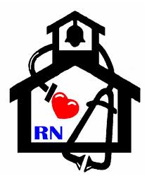
Nurse’s Nook
Pearl Lower Elementary – August
Aly Weems, School Nurse
Dear parents,
I would like to take this time to inform you that Pearl Lower Elementary currently receives a tobacco grant. In turn, this means I, as the school nurse, must spend so much of my time educating about tobacco use. I will do this by decorating my door and bulletin boards, posting a daily tobacco fact in the hall, and also sending home a monthly “Nurse’s Nook” to educate families on the harmful effects of tobacco use. I hope that this will benefit you and your families. Thank you for allowing me to take care of your little pirates!
Nurse Aly

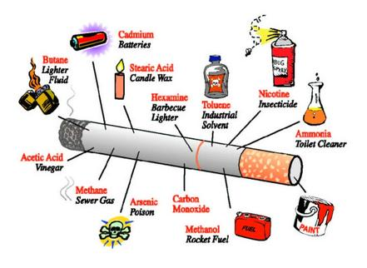
General Tobacco Facts
- Cigarettes contain more than 7,000 harmful chemicals, including those found in bug spray and moth balls.
- 5,400 Mississippi deaths result each year from smoking.
- Annual healthcare costs in Mississippi directly caused by smoking are $1.23 billion.
- Secondhand smoke causes coughing, colds, earaches, and worsens asthma.
- Smoking can cause cancer and heart disease.
- If you or a loved one needs help quitting, you can call 1-800-QUITNOW or 1-800-784-8699! It’s never too late to quit!

